Task 1:

What is a thread and a Process?
A process is a program that is running. Like opening Chrome or Word — each is a separate process.
A thread is a small part of a process that does some work. A process can have many threads doing different tasks at the same time.

Task 2:
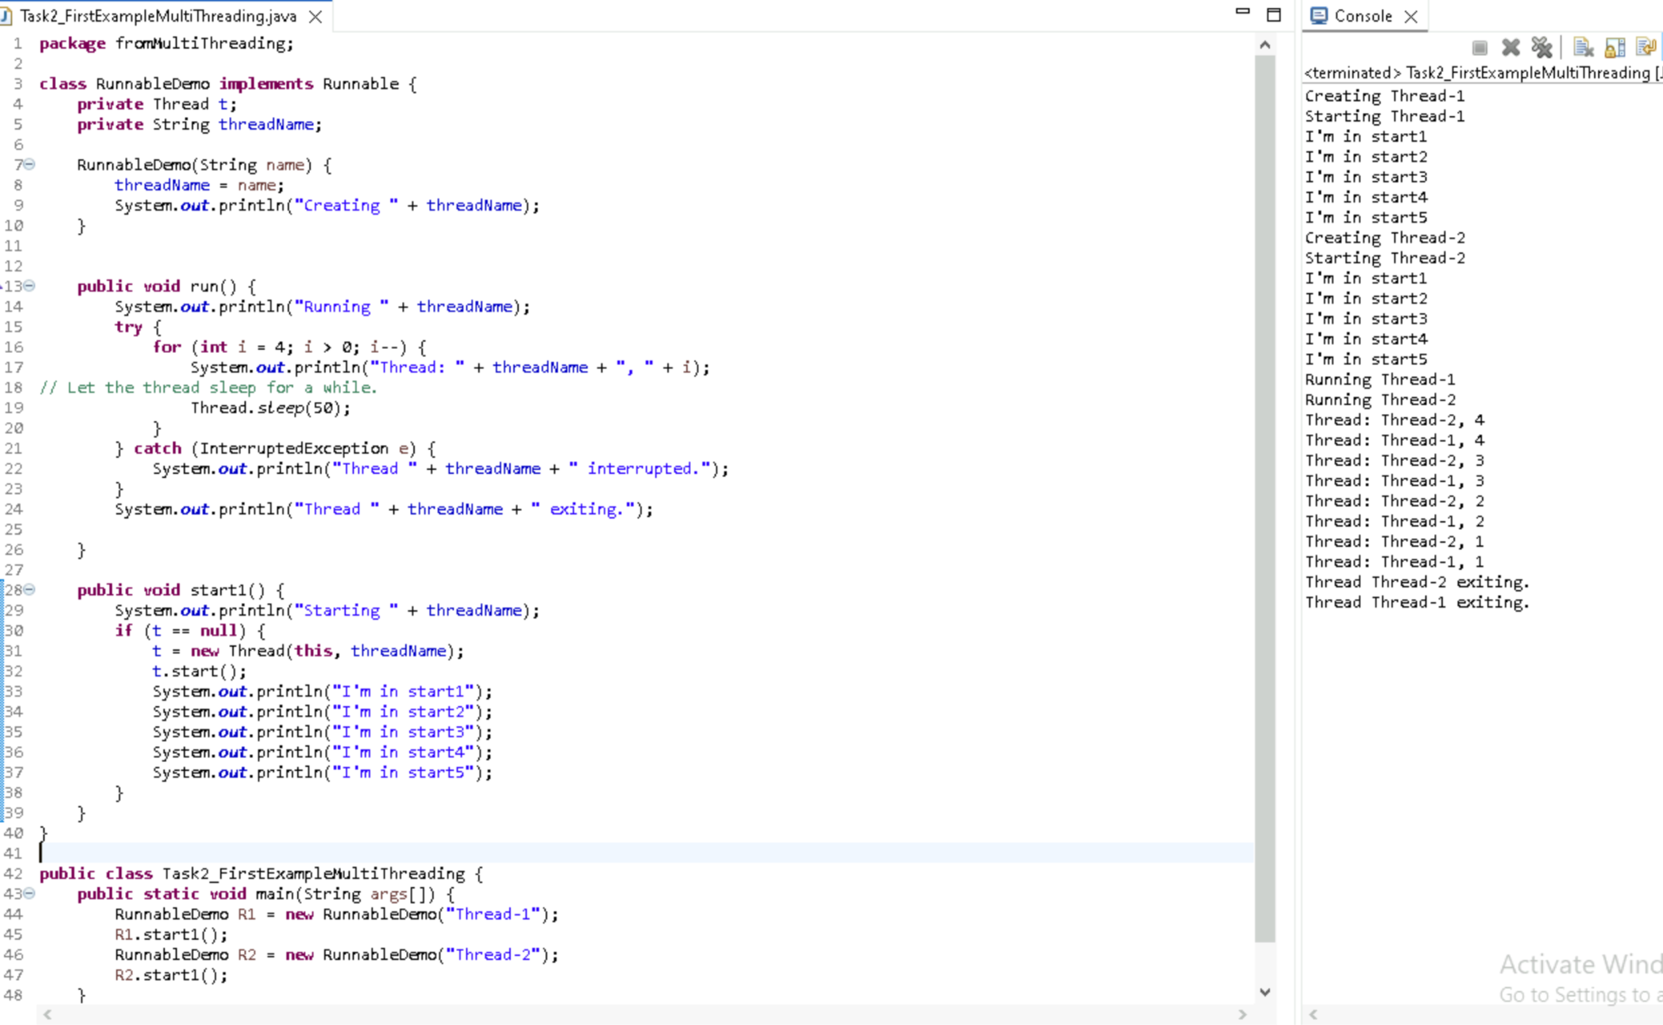

Task 3::
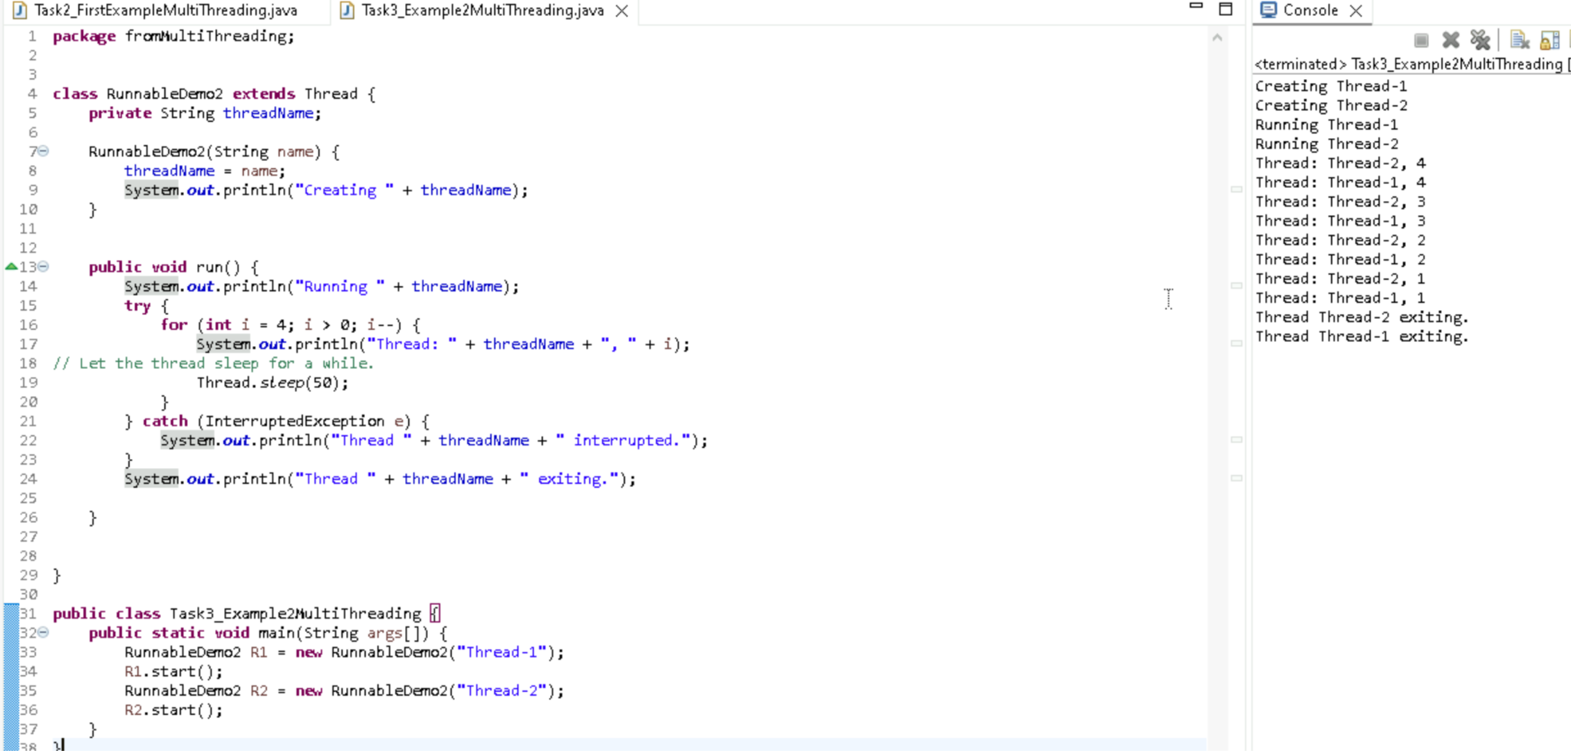

Task4::
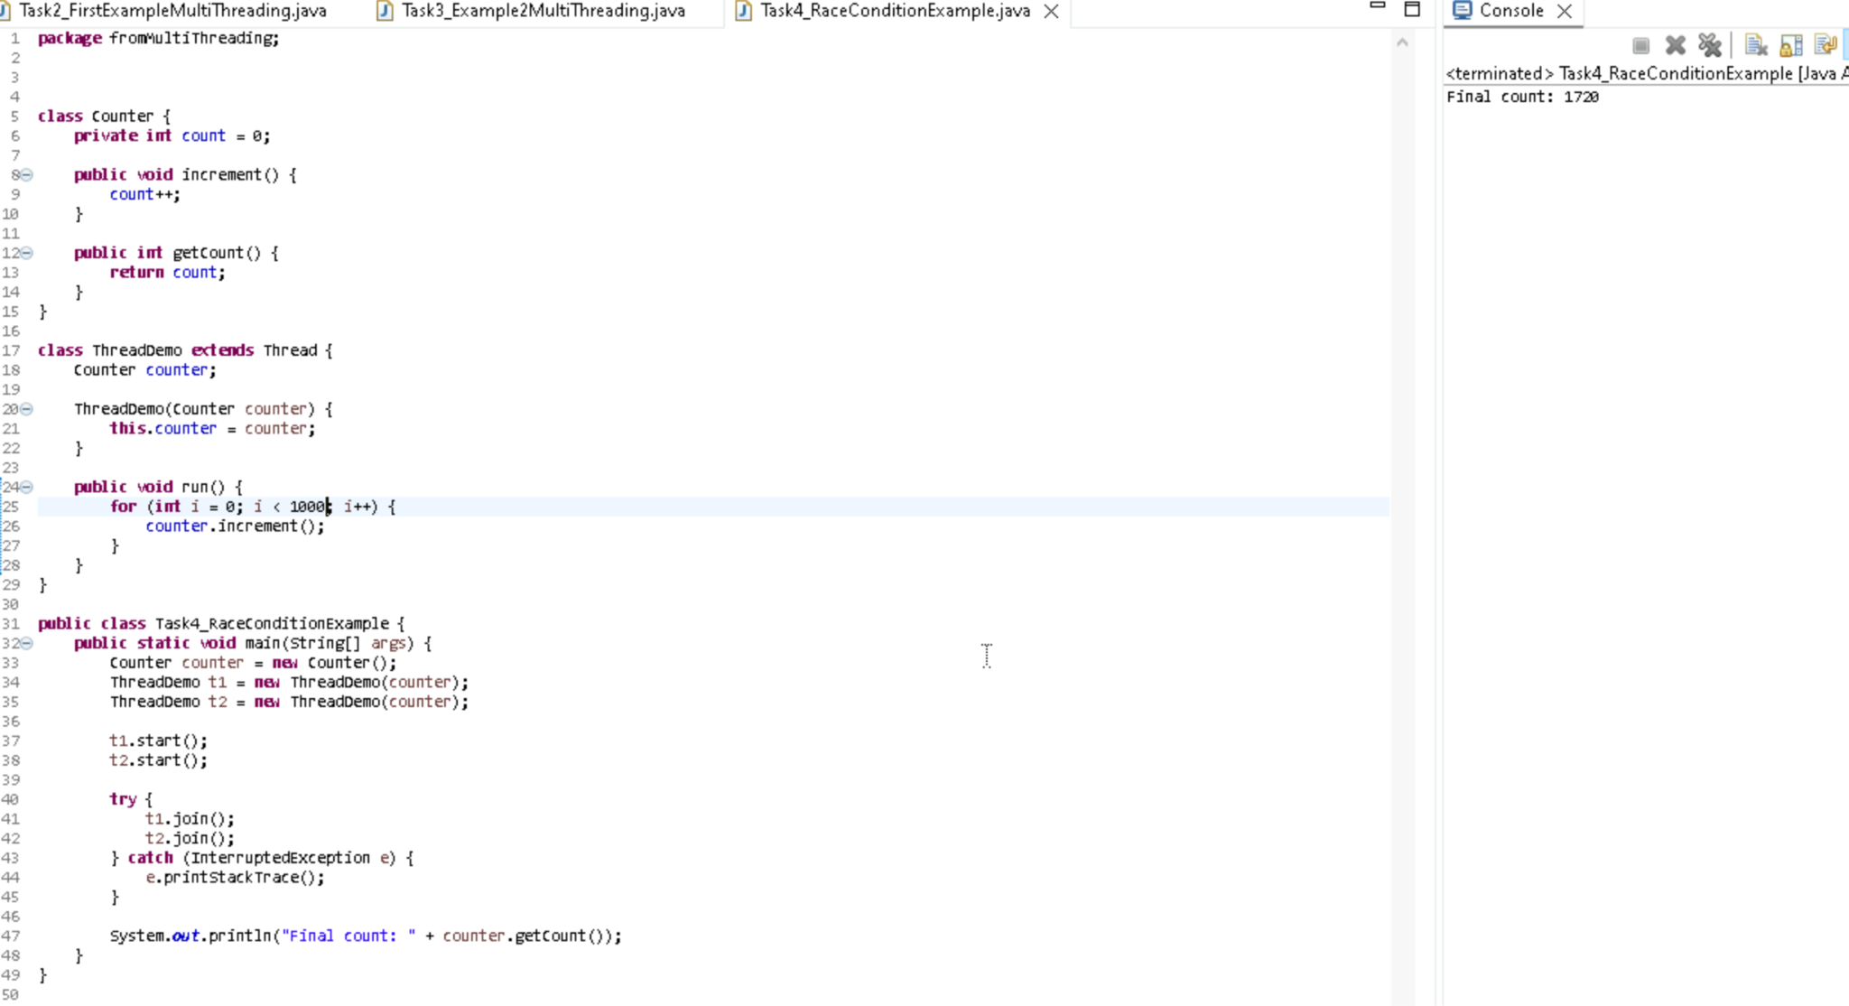

Task5::
Synchronised method
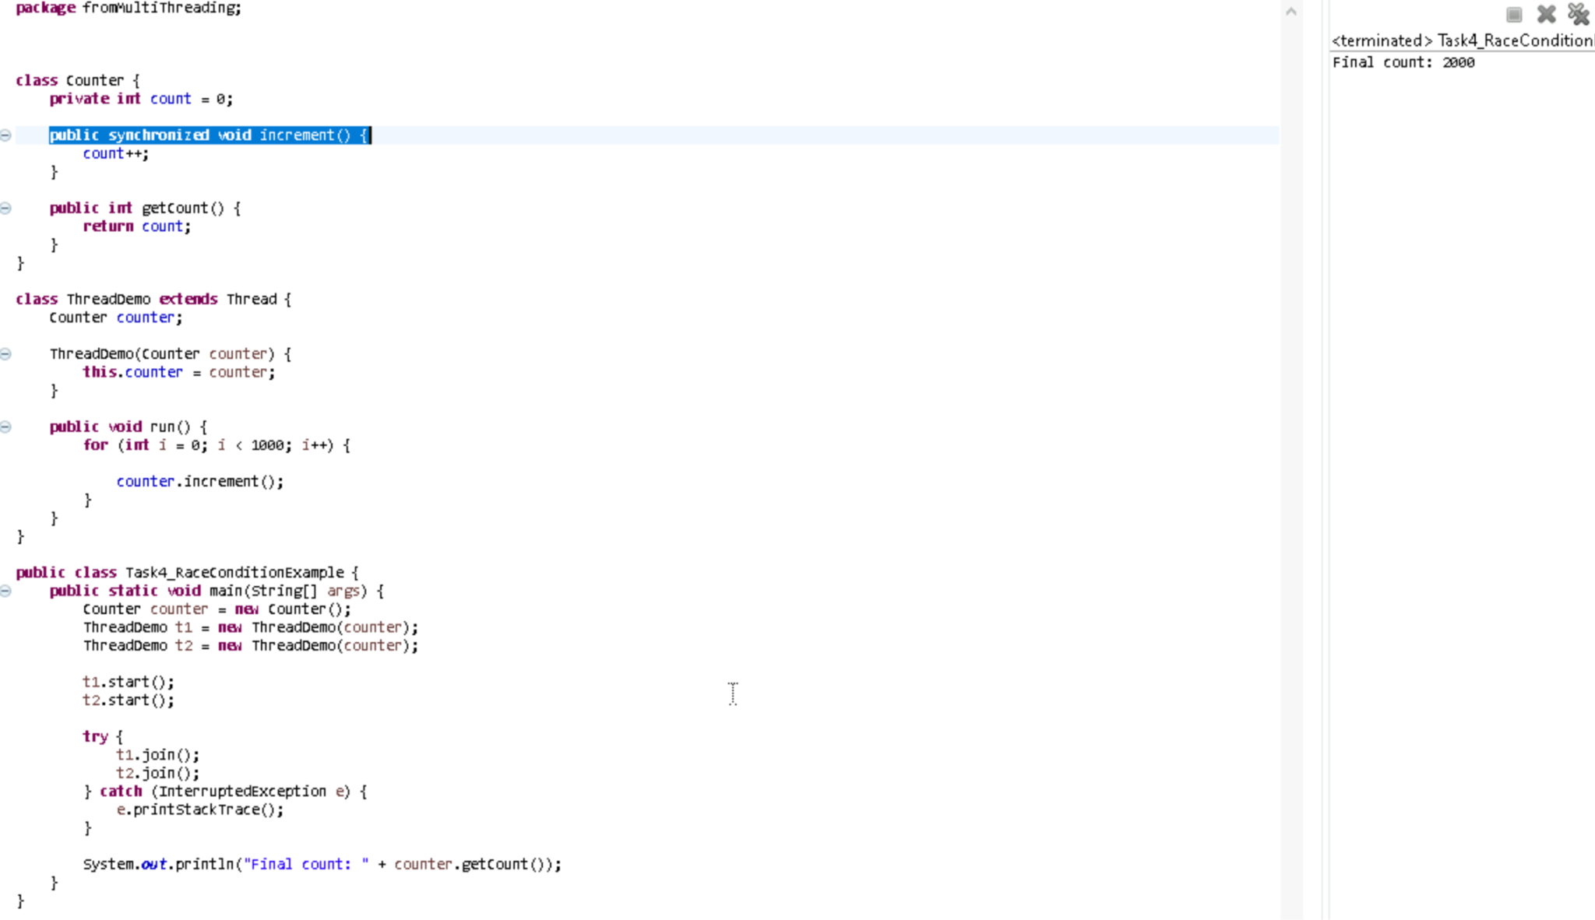

Task6::
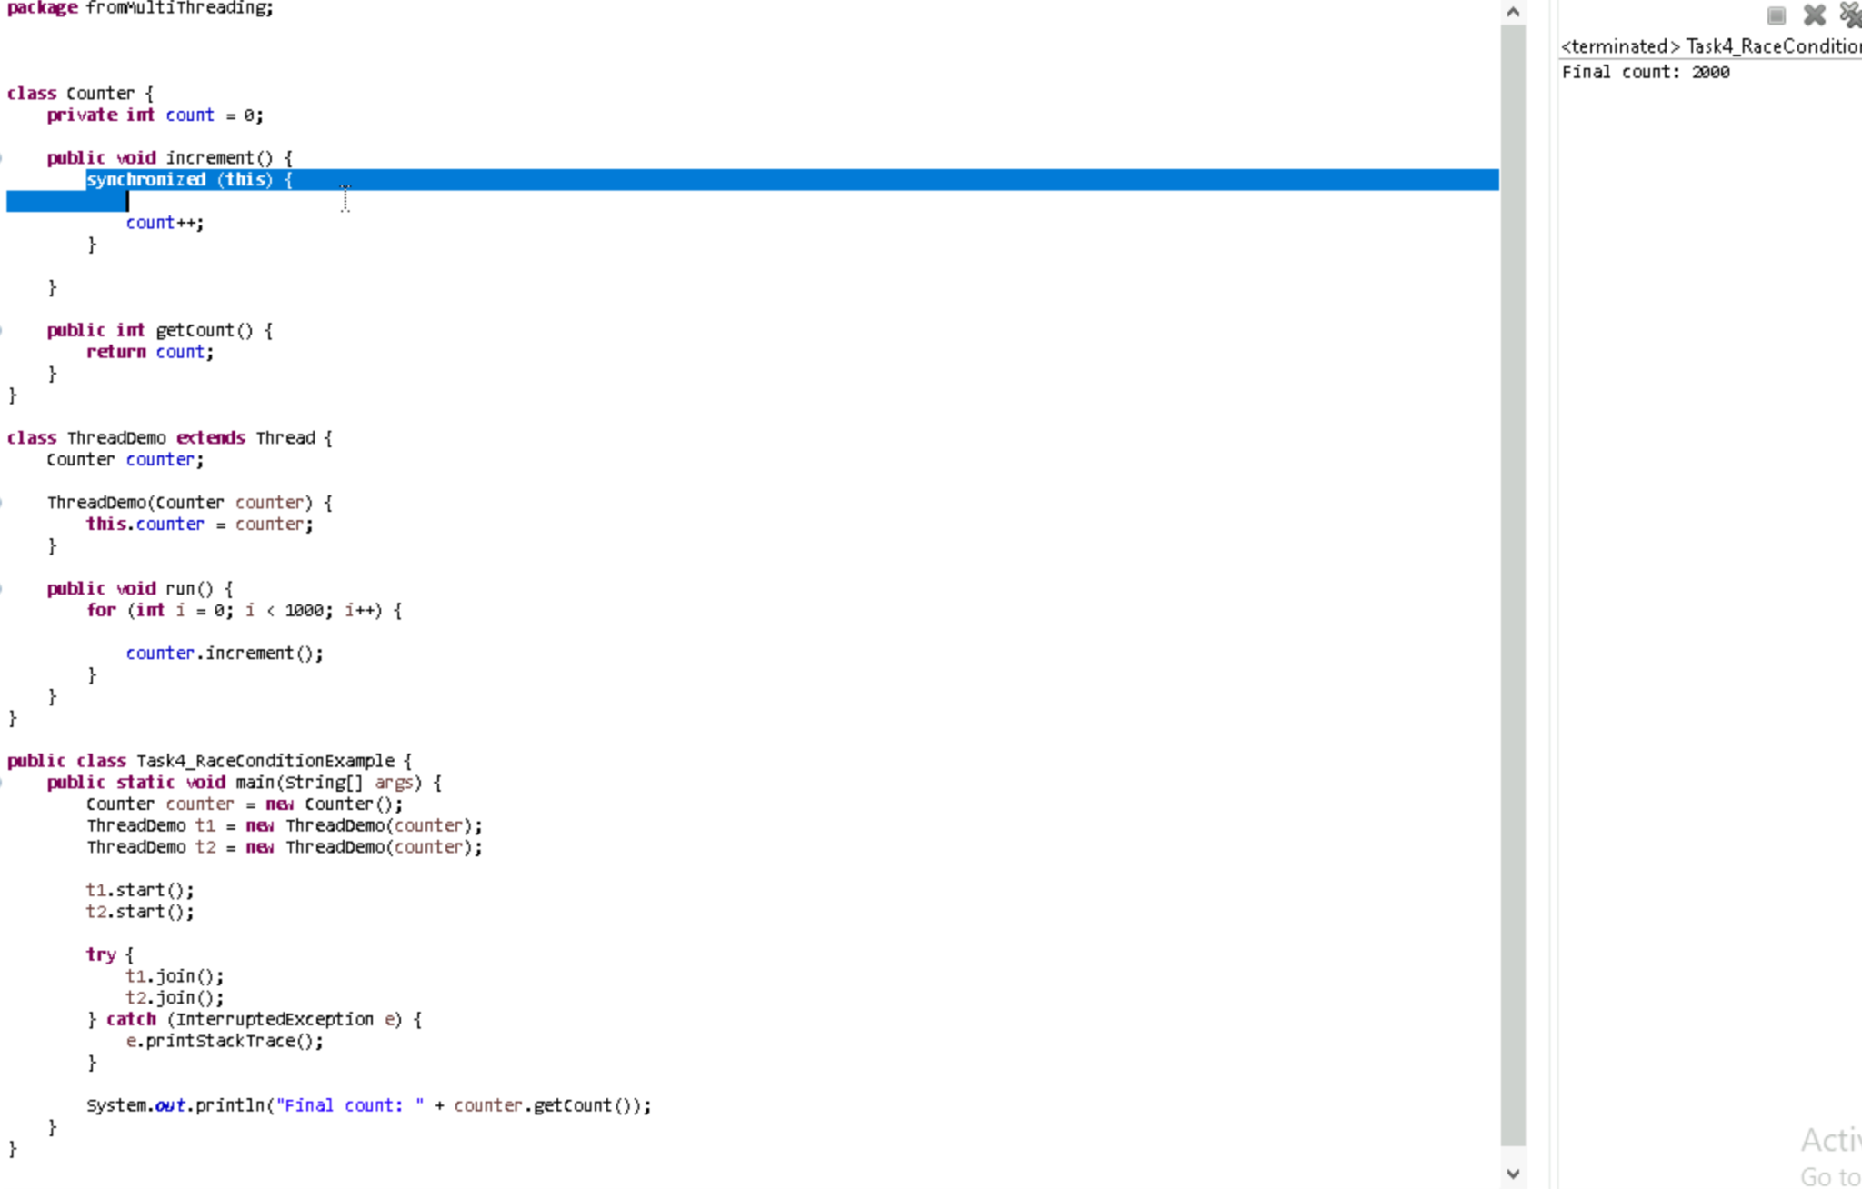

Task7::
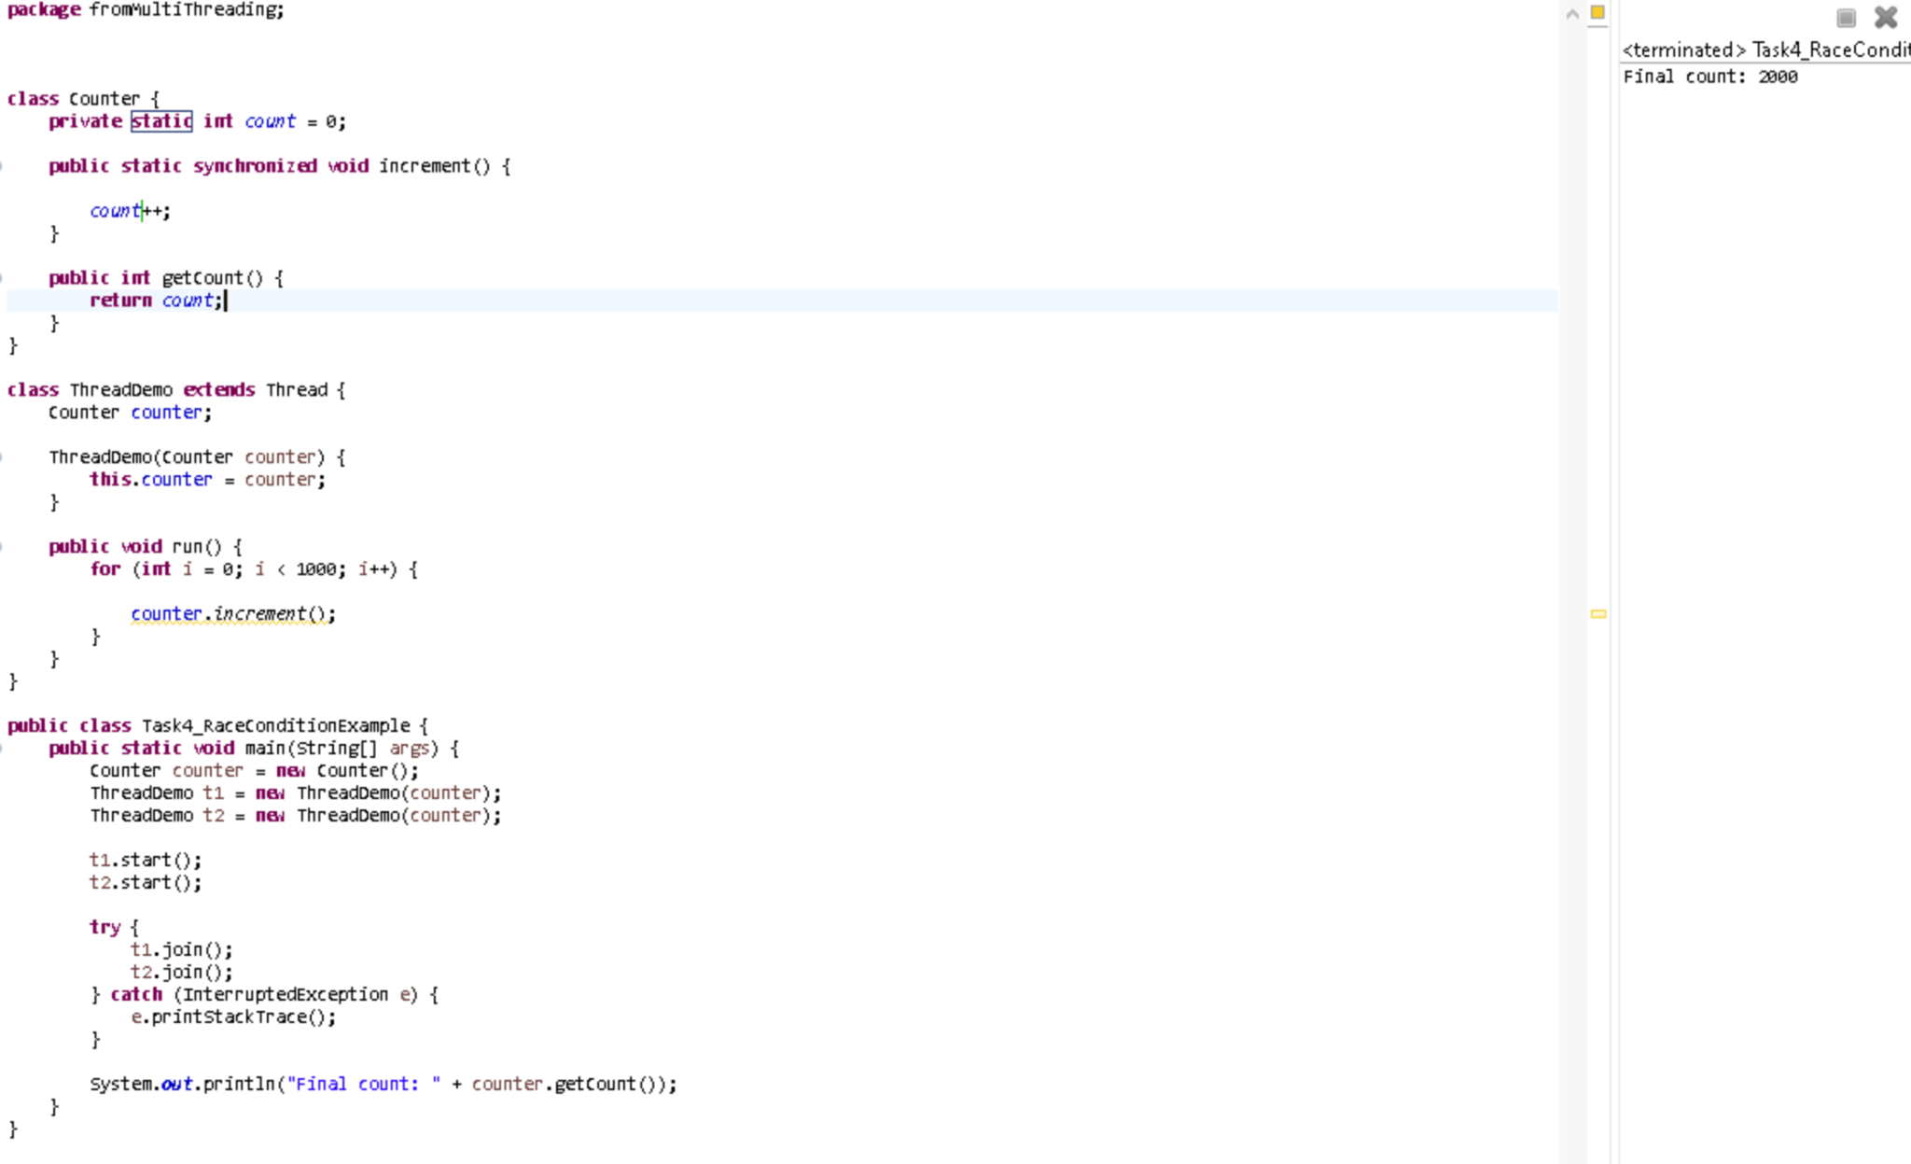

Task8::
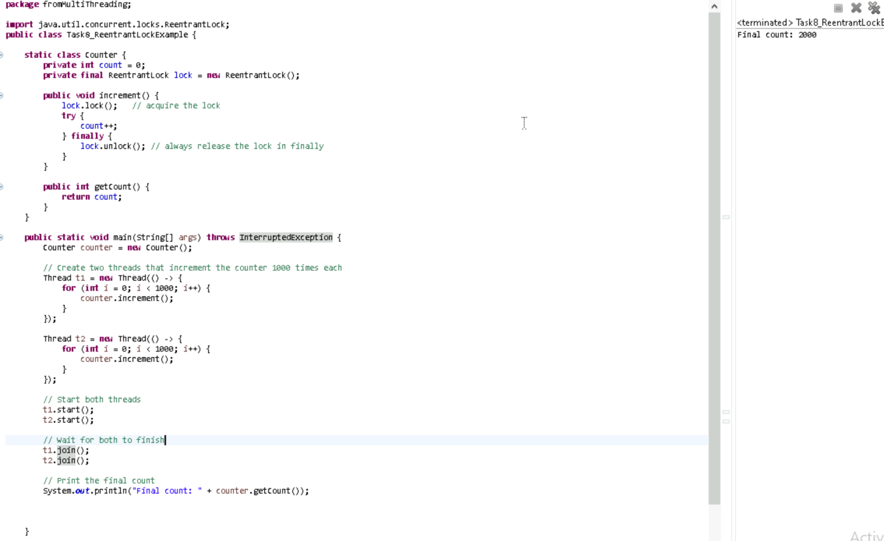
Task10::
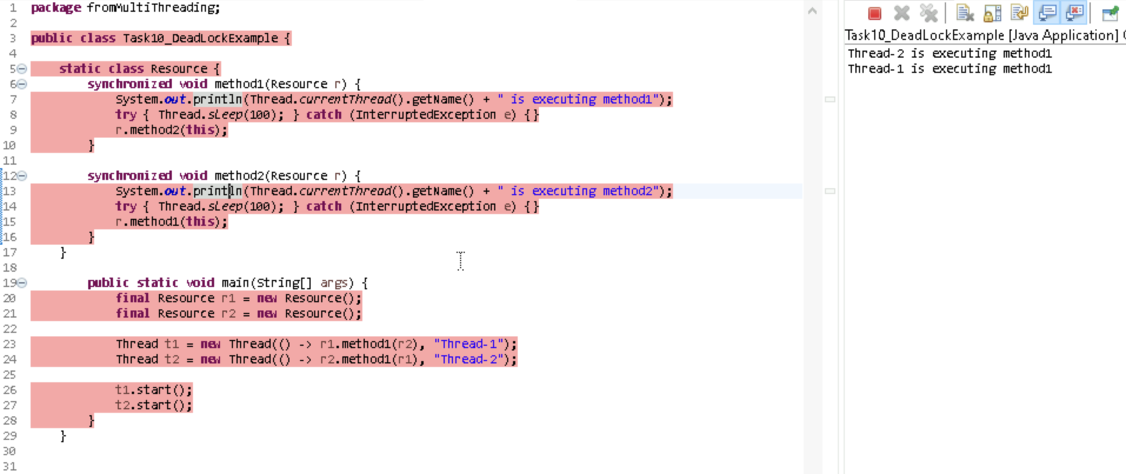

Task11::
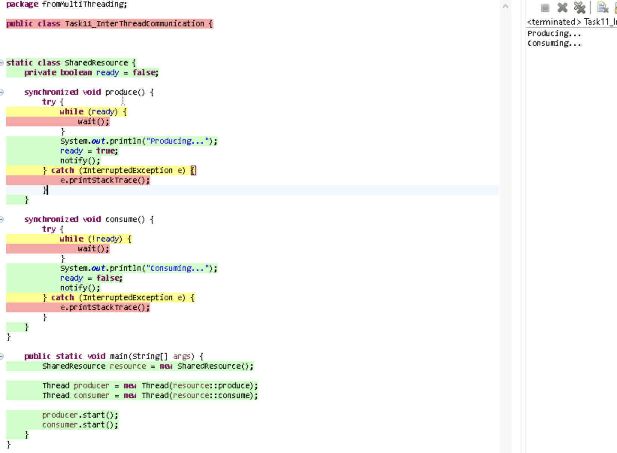
Task12::
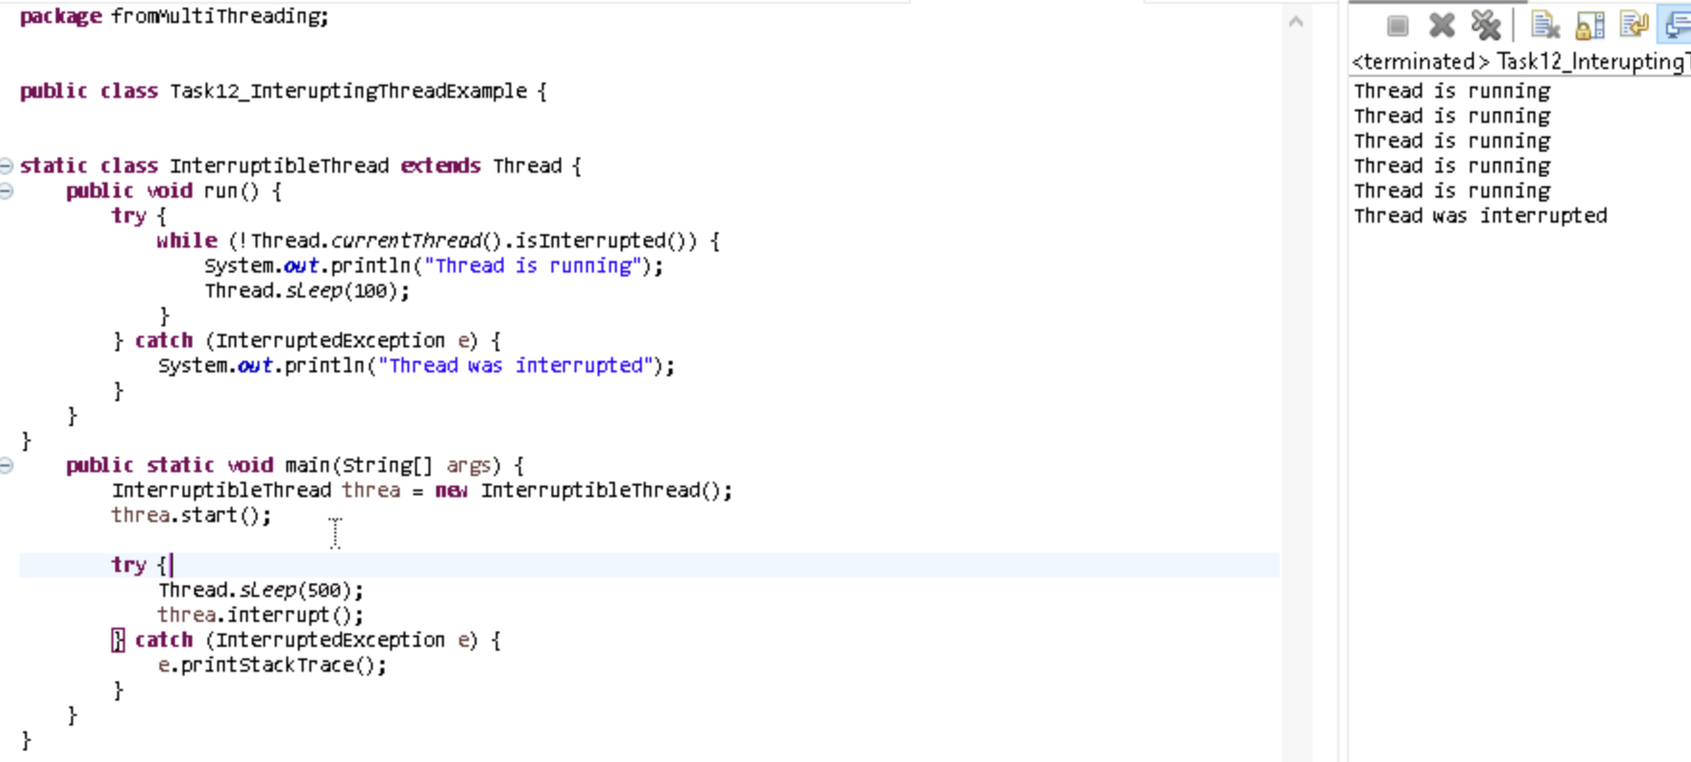

Task 14::

What is Thread pool?
A Thread Pool is a group of pre-created threads that are kept ready to do tasks.
Instead of creating a new thread every time (which is slow), the thread pool gives you a free thread from the pool, runs your task, and then reuses the thread for the next task.

Task15::
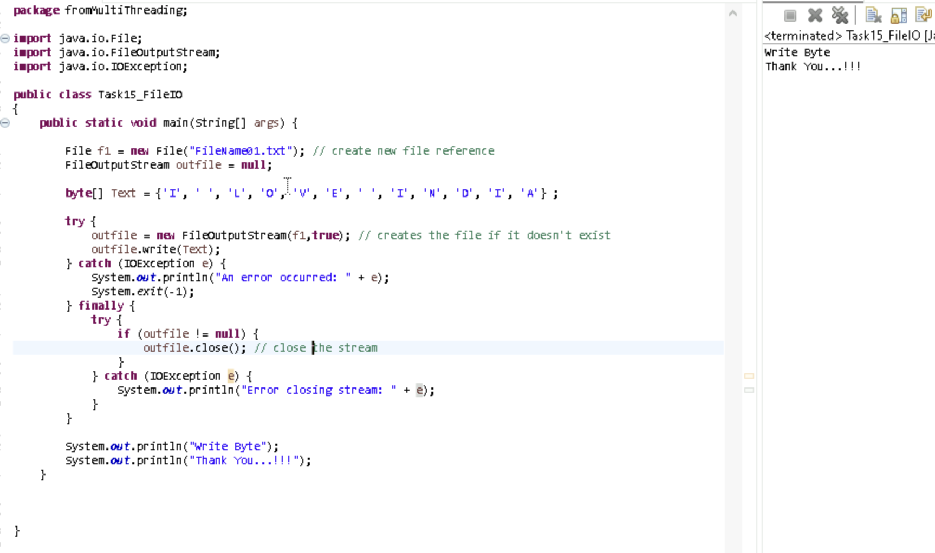

Task16 ::
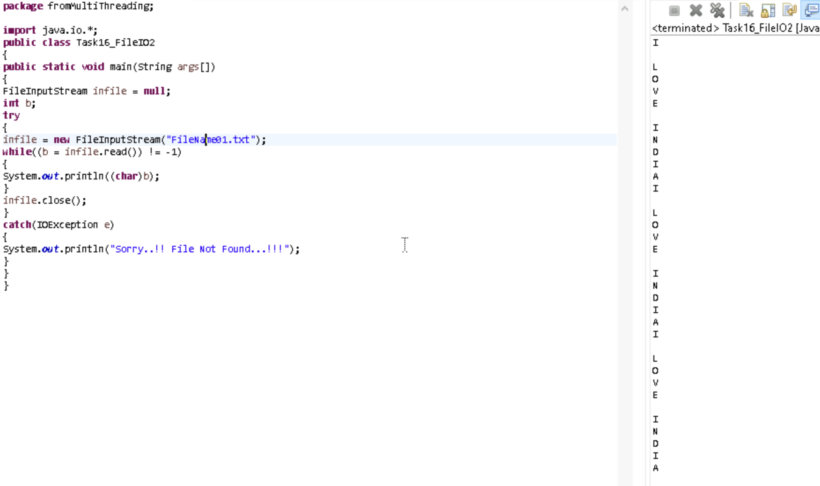

Task17::
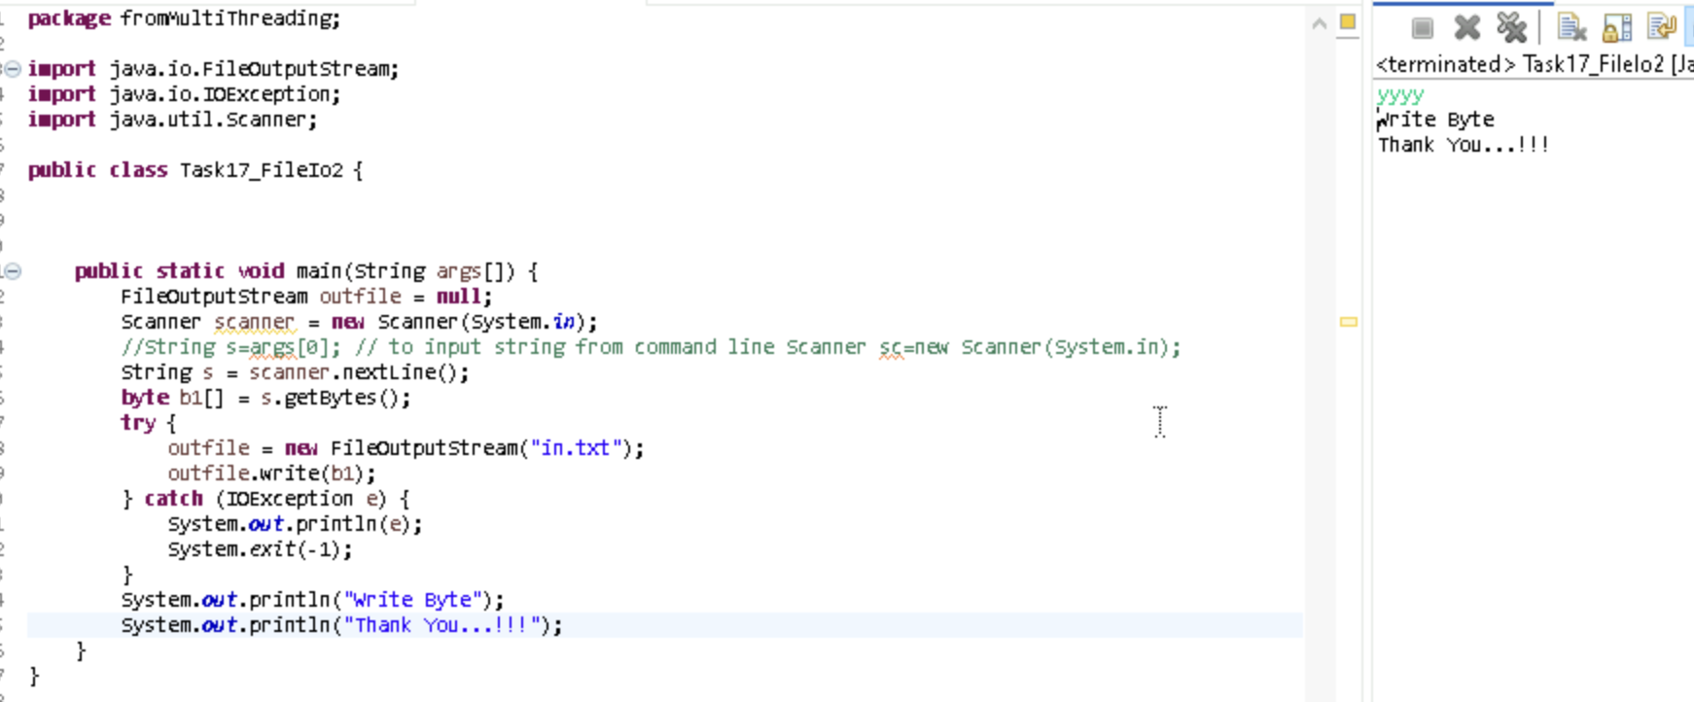

Task18 ::
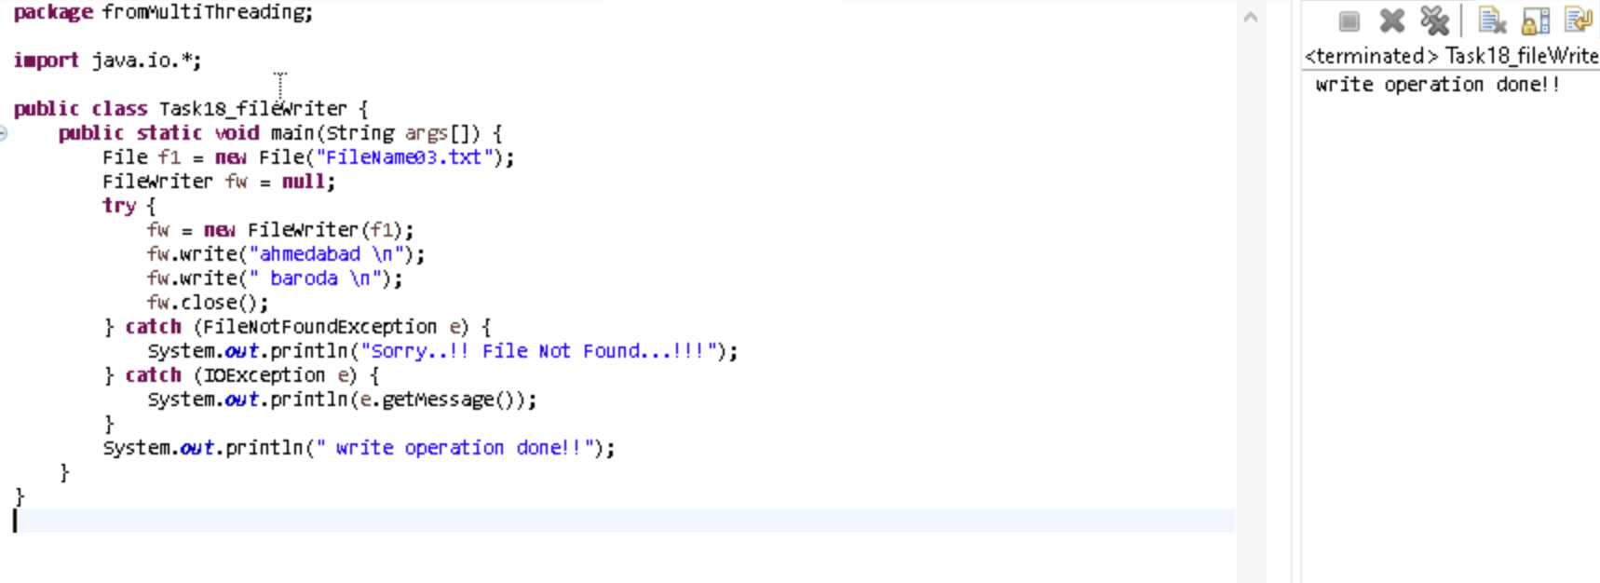
Task19::
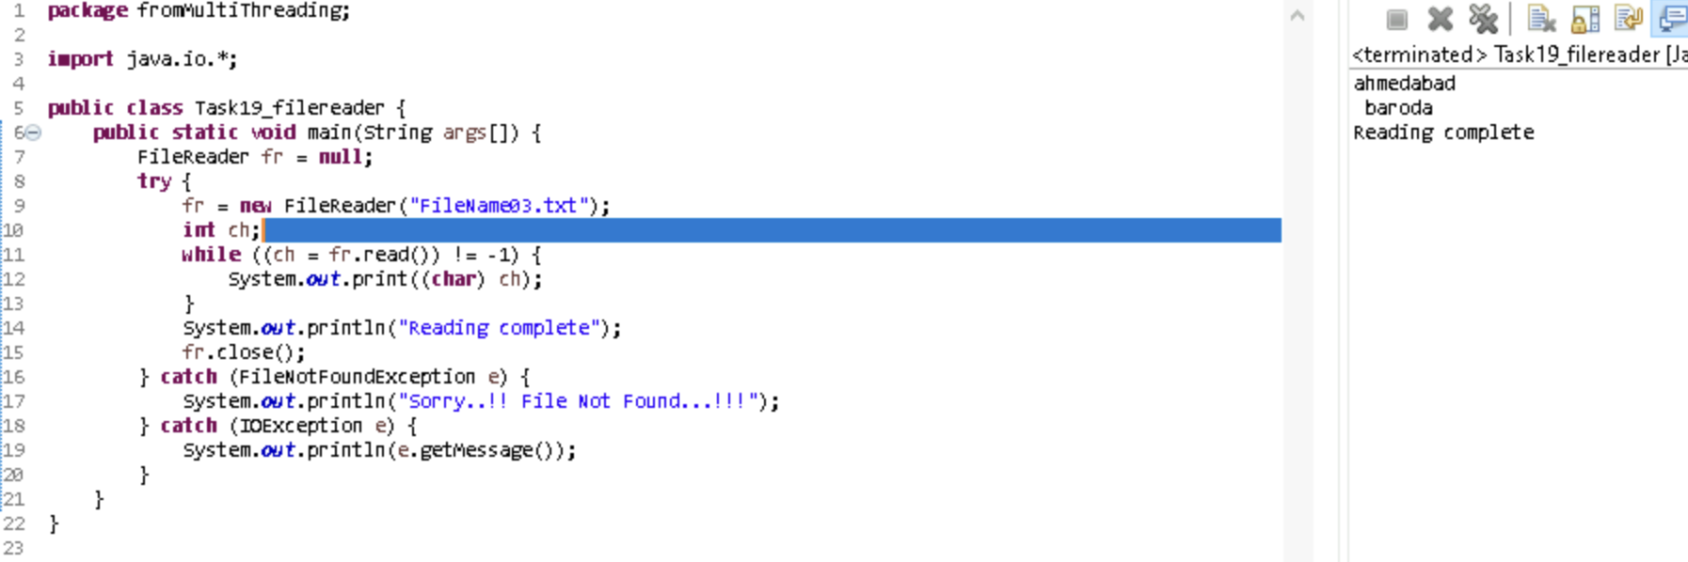

Task20 ::
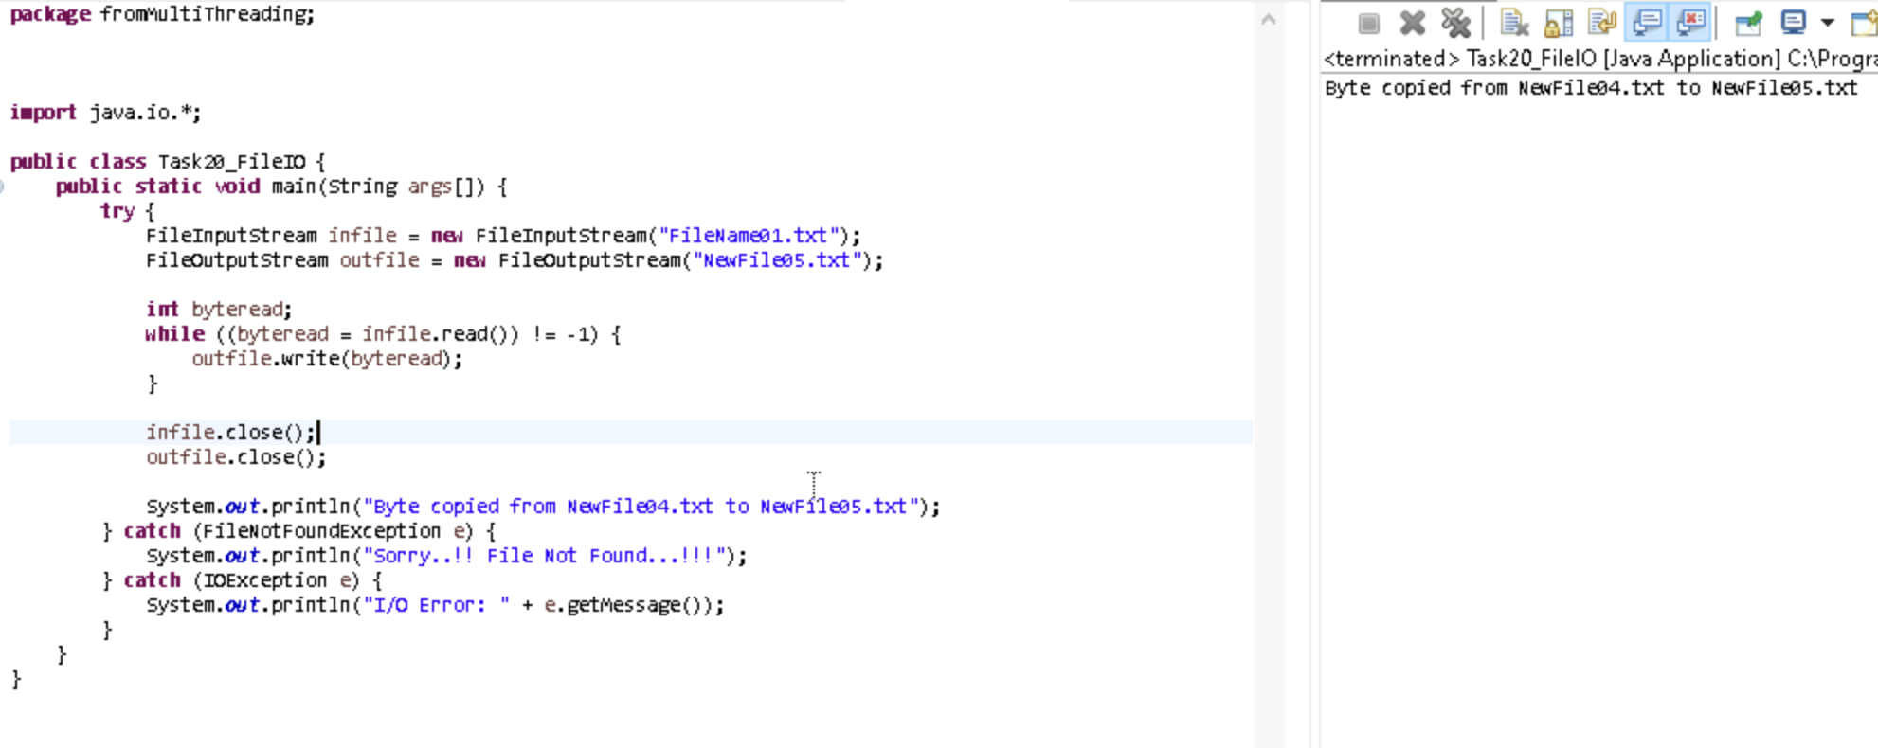

Task21::
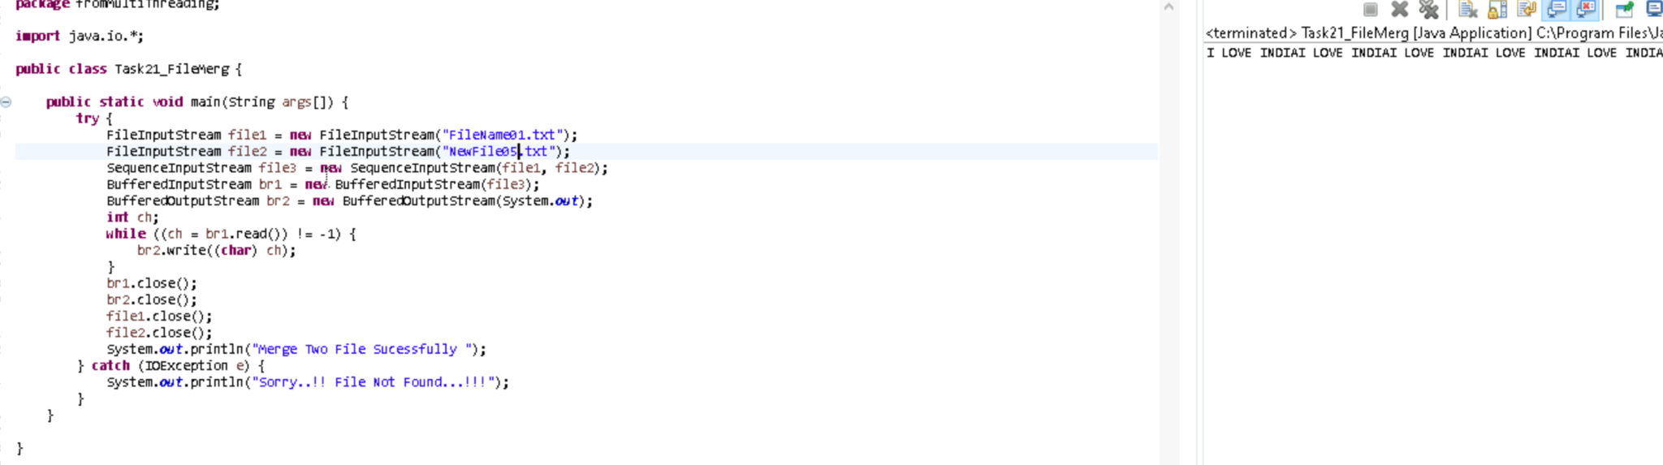

Task22::
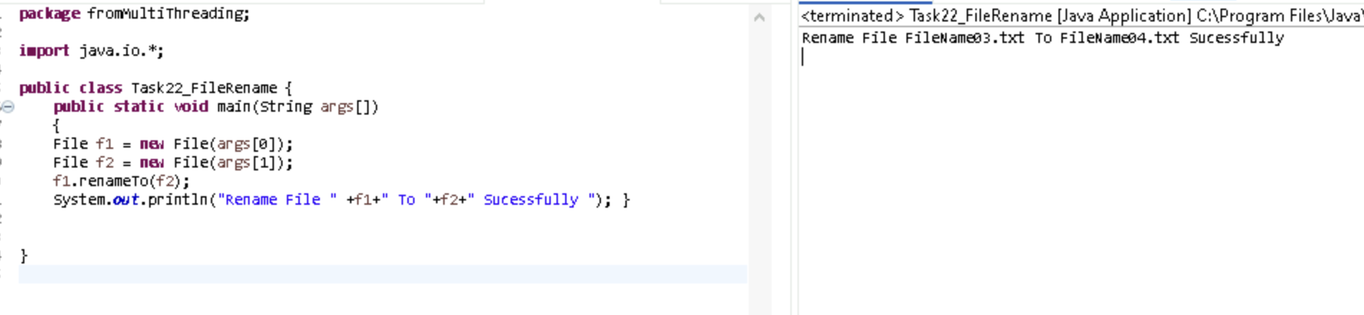

Task23::
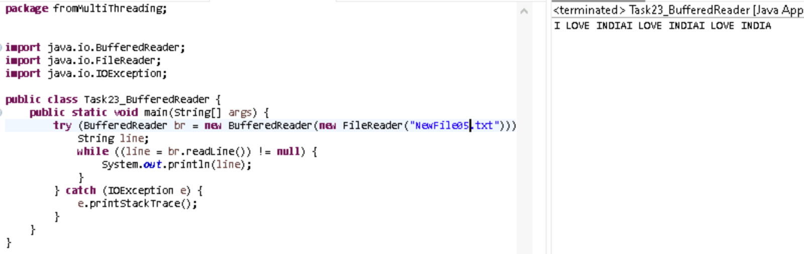

Task24::
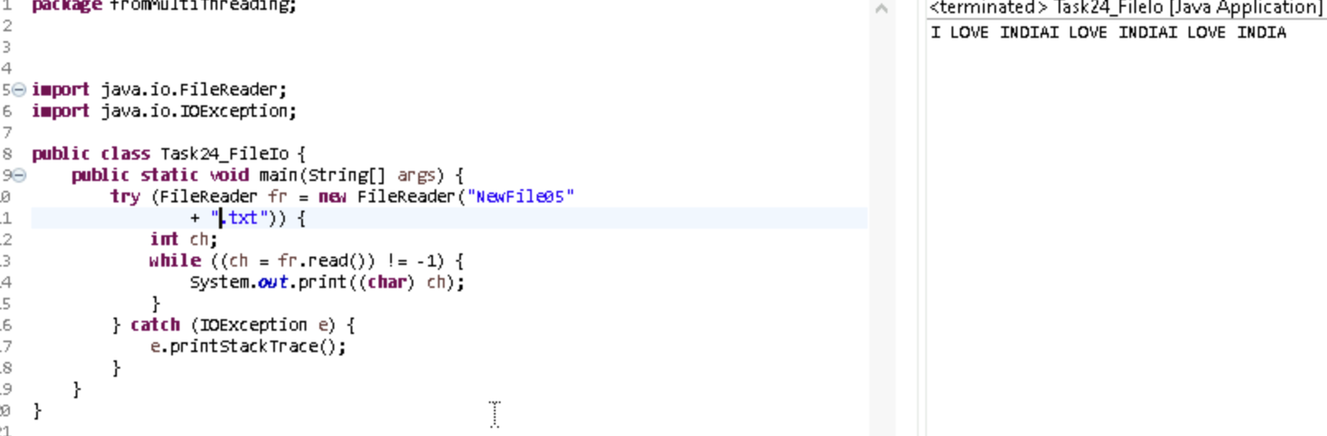

Task25::
